**DIGITAL MARKETTING**

Assignment 2 -Creating a facebook page and posting a social media poster

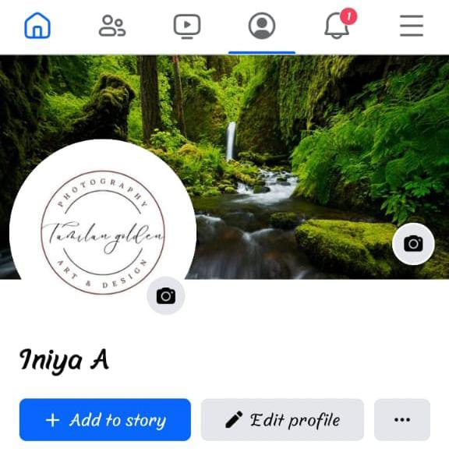



Fig : Social media poster

**Facebook post link:**

https://m.facebook.com/story.php?story_fbid=pfbid02v9b5WHoNA22NShjNnctUHnnZf9jJCwcPPxULFut1TbdiWC98qGS6i1dancq4rDpHl&id=61552545008787&mibextid=Nif5oz